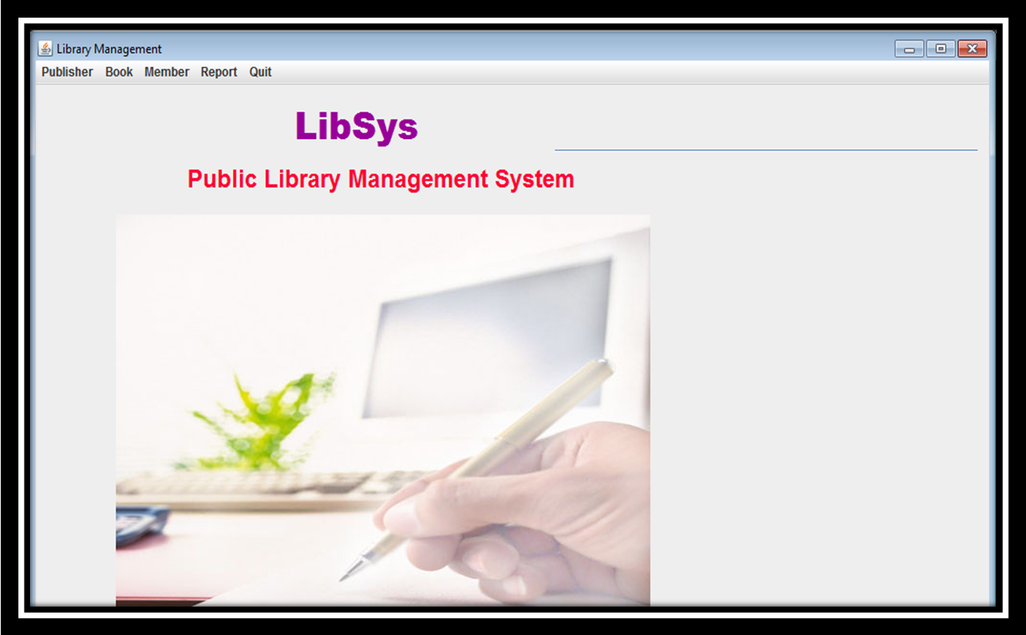
DIGITAL LIBRARY MANAGEMENT SYSTEM..!!
EXIT



MEMBER BOOK DETAILS PUBLISHER ISSUE HELP

